Chapter 3 Equilibrium of forces
Chapter Test Total marks 42

Name: __________________________ Class: ______ Date: ______
A data sheet with appropriate physics constants will be provided for this test.
Question 1
At a building site, a pulley system operated by an electric motor is used to lift bricks to the upper floors of the building. The motor can supply a torque of 750 N m. The pulley operated by the motor has a radius of 18 cm. The diagram below shows the system.

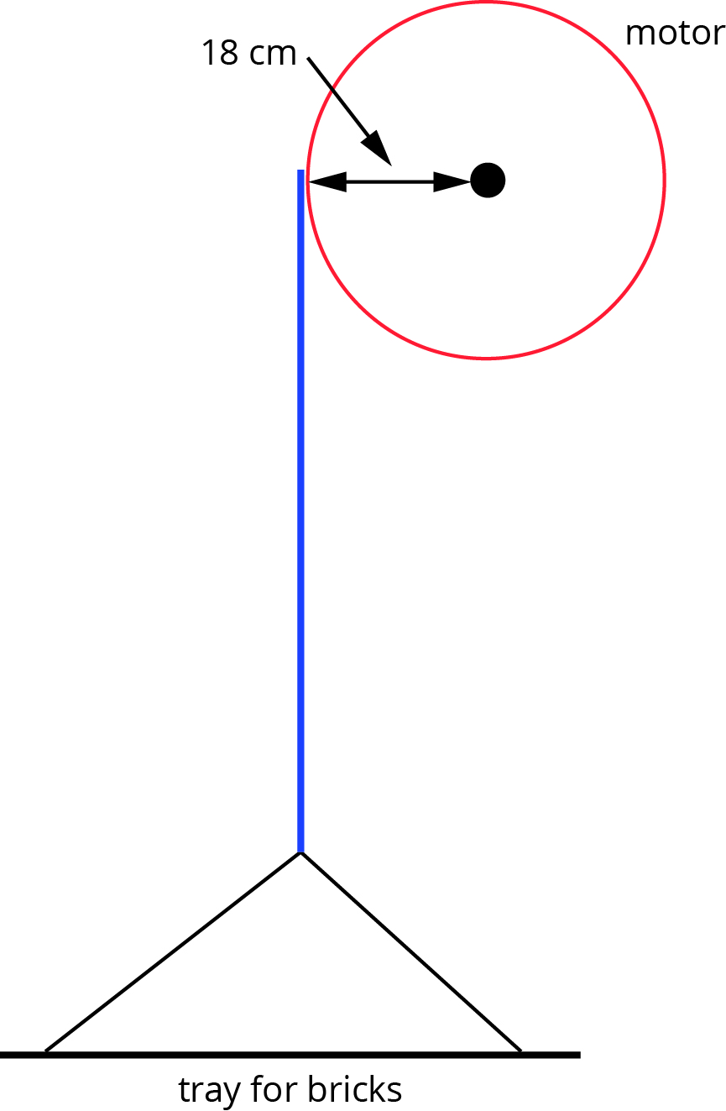

What is the maximum mass of bricks the winch can lift? (3 marks)

Question 2
You are working as a designer of home plumbing fittings and are asked to design a tap that is easy to turn for people with conditions such as arthritis or older people with less strength in their arms. Sketch a labelled diagram of your tap design below and explain the physics principles in your design that will make it easy to turn. (3 marks)

Question 3
The diagrams below show designs for two vases. The centre of mass, G, is marked on each.
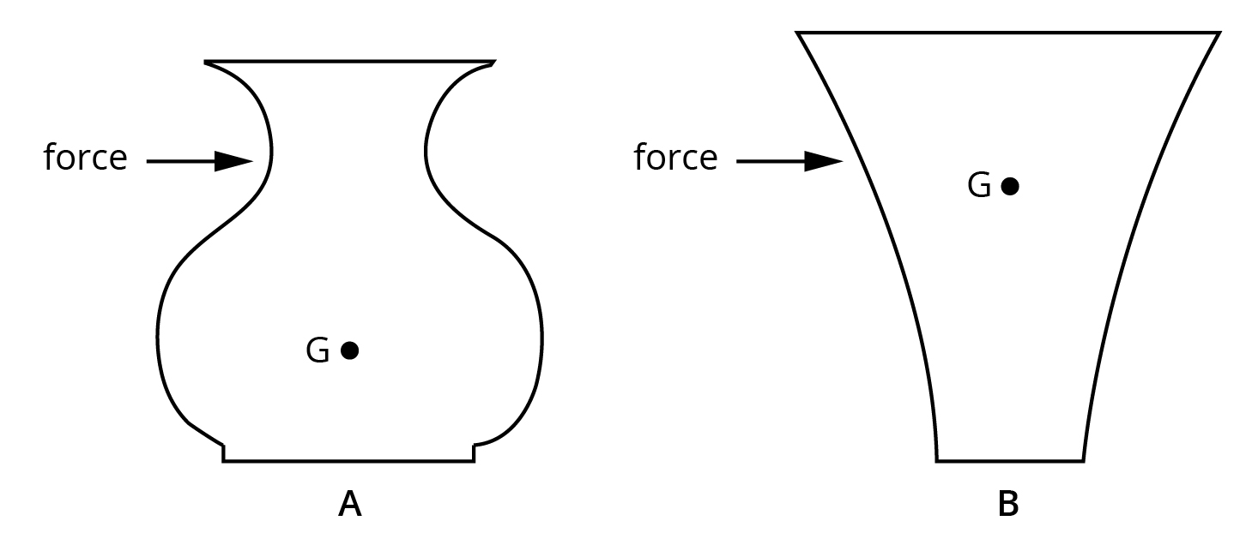

State which of the two vases is more stable. Using the appropriate physics principles, explain your answer. In your answer give the reason the less stable vase will tip over. Sketch labelled lines on the diagrams to illustrate your answer. (4 marks)

Question 4
Large tower cranes such as the one shown below are often seen on construction sites. They do not have a single load limit but rather have a table giving the maximum load for each metre of distance the load is along the jib.
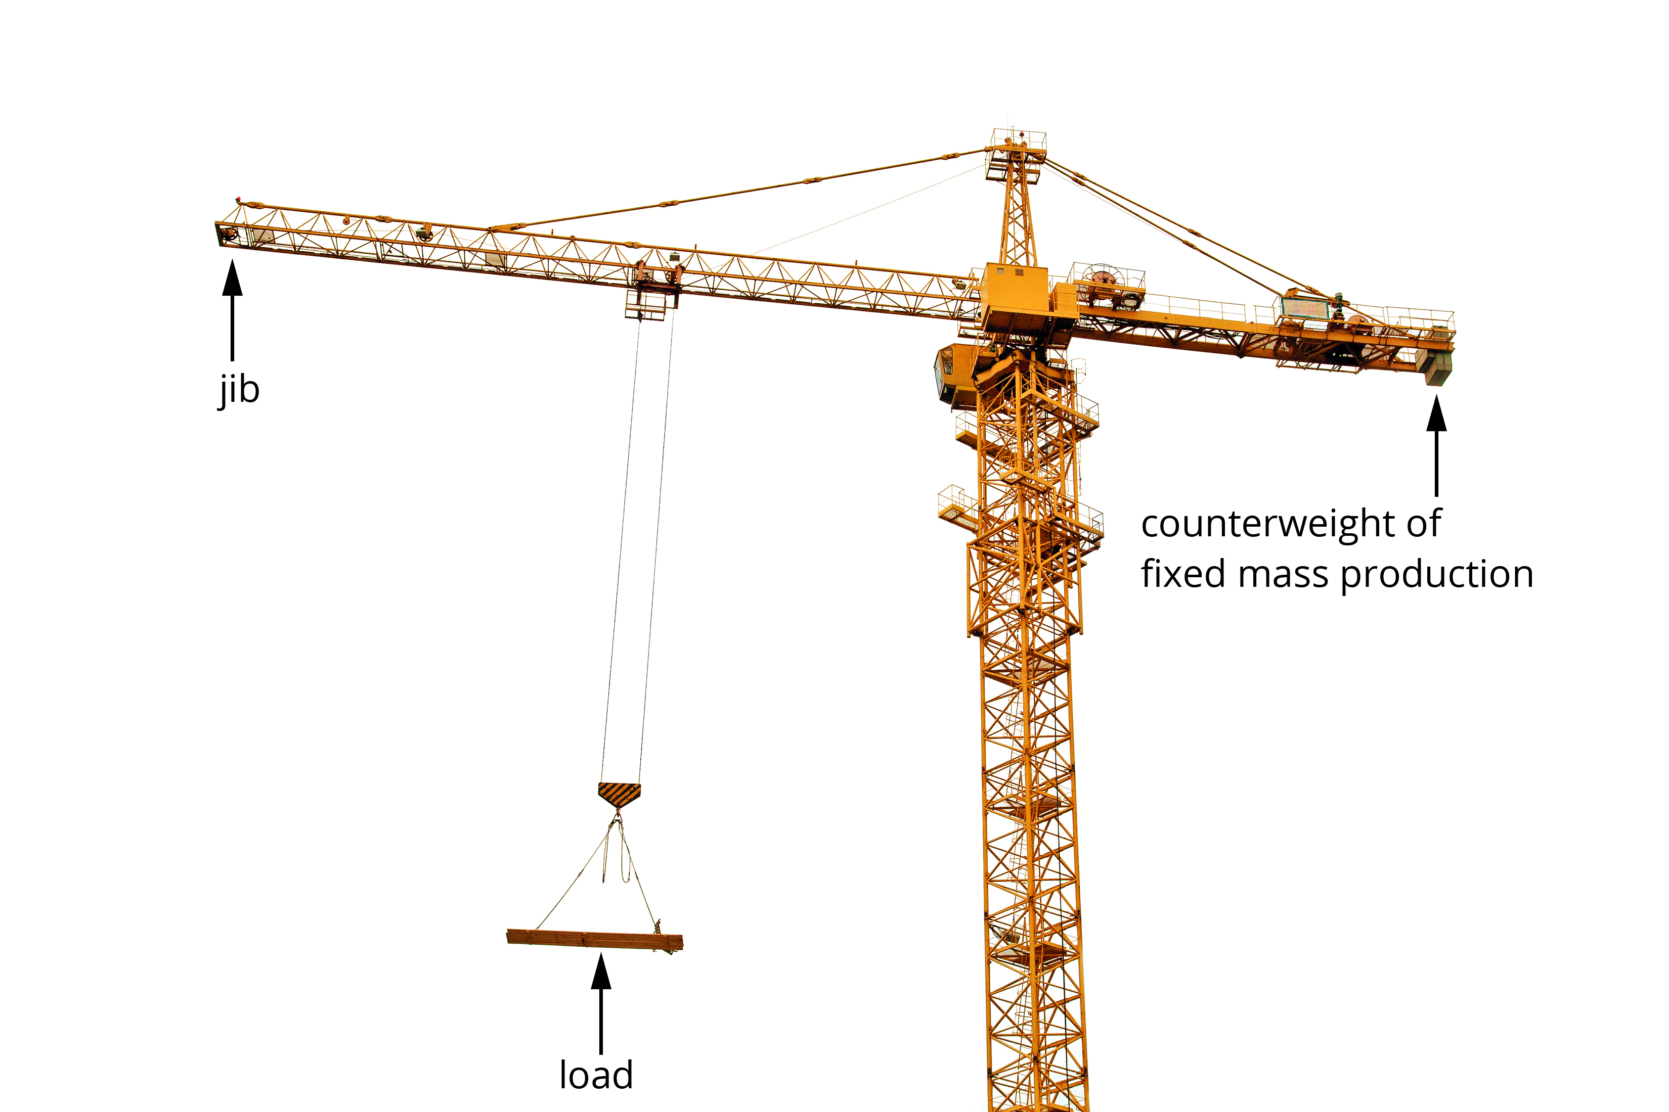

If you determine the product of the load and distance along the jib in each case, what would you expect the result to be? Explain your answer. (3 marks)

Question 5
The French theatre company Royal de Luxe uses giant puppets for street art. One of the giants, a diver, is 9.5 m tall and has a mass of 2.5 tonnes (1 tonne = 1000 kg). The giant is made to ‘walk’ by a series of pulleys attached to the arm of a crane overhead and operated by the weight of two people pulling on a pulley rope to lift the legs.
Examine the diagram below to make an estimate of the tension needed in the rope to hold the upper leg (thigh) at the point indicated in the picture. A simplified line drawing of the head, torso and one leg is shown to assist. Clearly indicate the values you use to determine your estimate of the tension in the rope. The line drawing can be drawn on to assist in determining estimates. (10 marks)

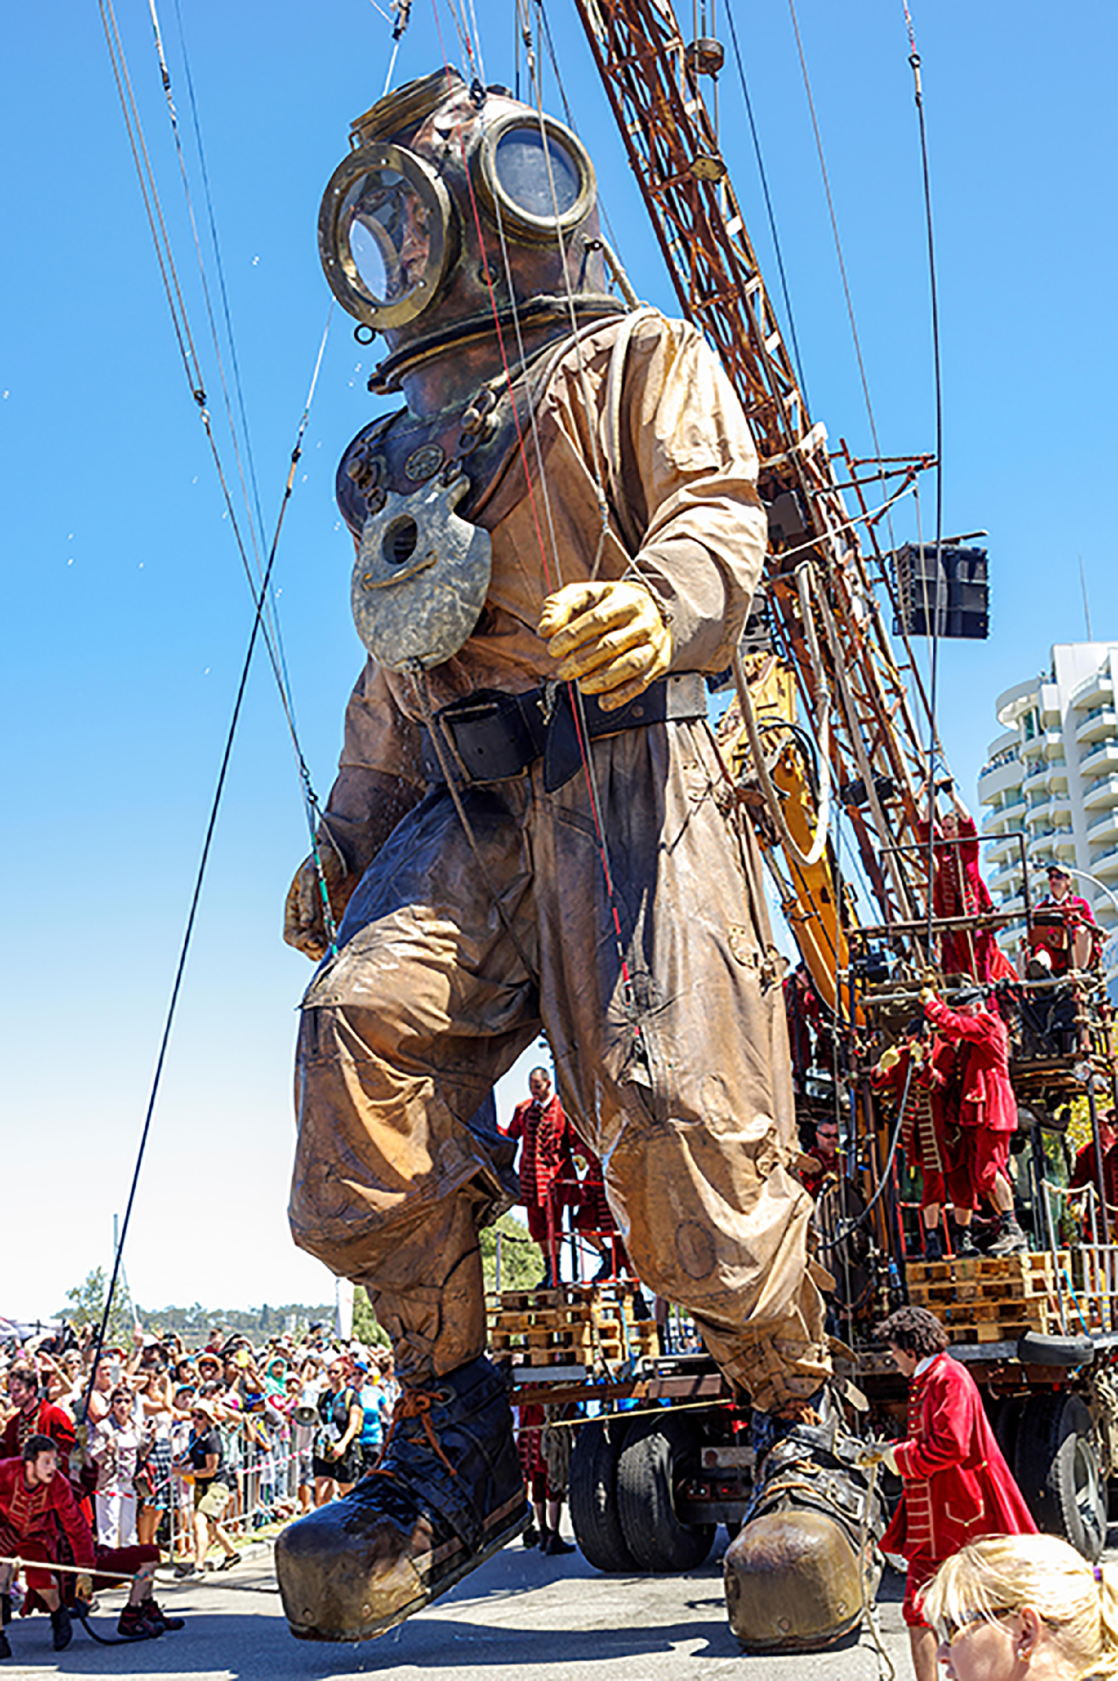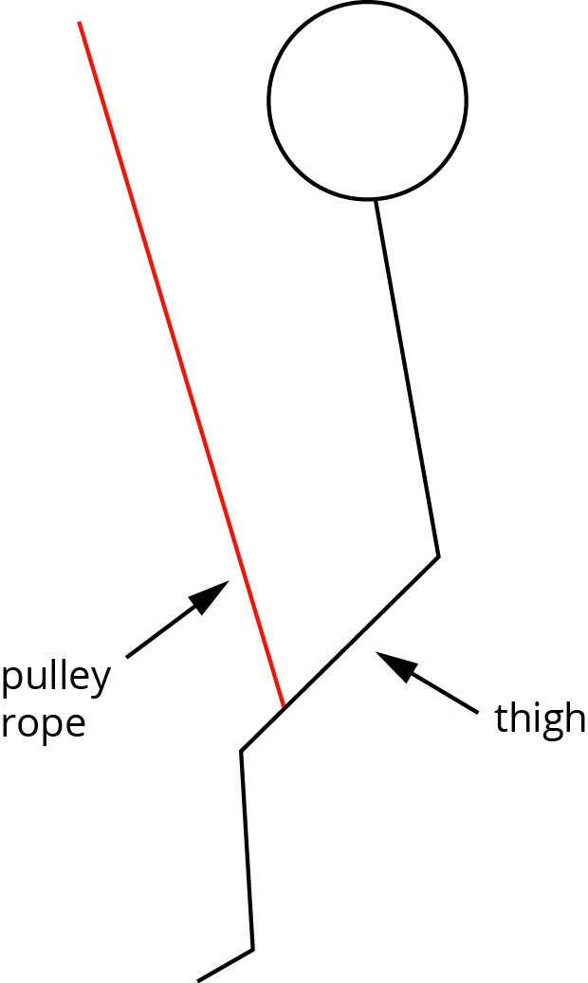

Question 6
While watching a bobcat moving large concrete pipes, Adrian notices that when attempting to lift one large pipe positioned near the end of the forks furthest from the machine, the rear of the bobcat lifts off the ground. The operator then jiggles the pipe closer to the machine. The pipe is then successfully lifted. Explain these observations using the appropriate physics concepts. The diagram can be annotated to assist your explanation if you wish. (3 marks)

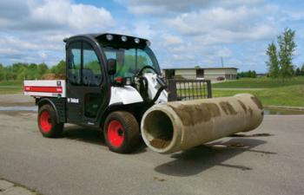
Source: © Jim Parkin/Alamy

Question 7
A bed consists of a uniform support base for the mattress, the bedhead and the end of the bed. The support base slots into metal supports on the bedhead and end of the bed, as shown in the diagram below. The bed has a length of 2.00 m, a uniform 20.00 kg mattress and the base has a mass of 50.00 kg.

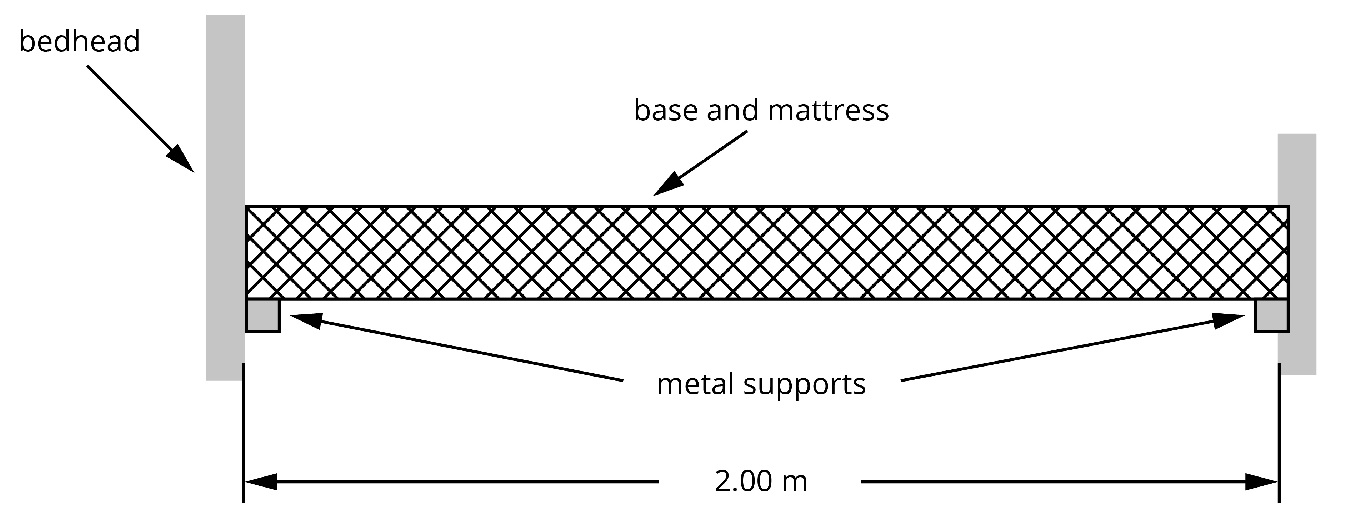

- If the centre of mass of a 65.0 kg person sleeping in the bed is 30.0 cm from the bed’s centre of mass, calculate the force provided by the metal support at the bedhead. Give your answer to the correct number of significant figures. (5 marks)

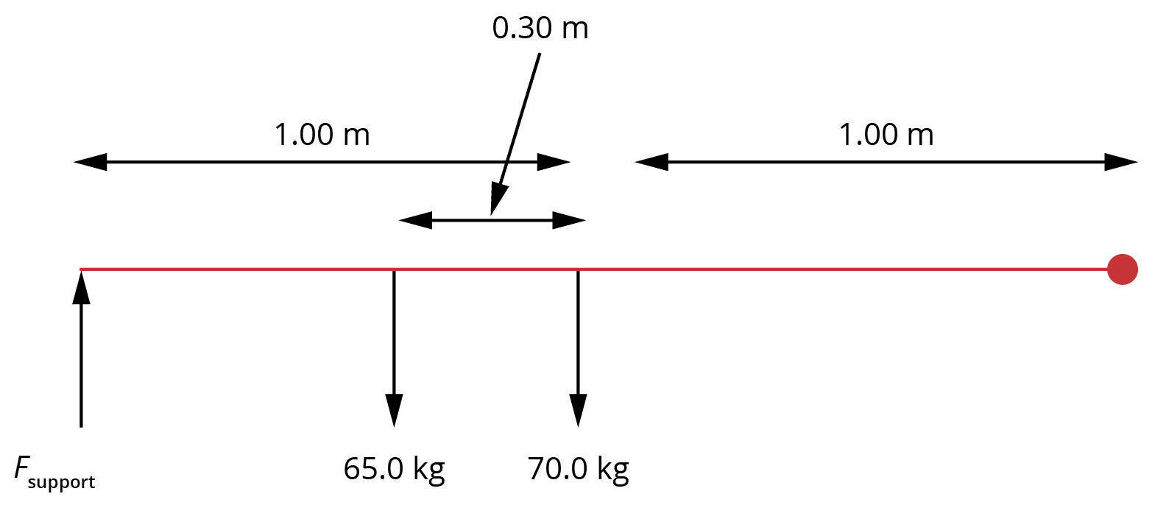

- What is the force provided by the support at the end of the bed when the 65.0 kg person is sleeping in the bed? (3 marks)

Question 8
A 75 kg sign is suspended from a uniform 8.5 kg wooden beam of length 2.2 m. The sign is 1.8 m from the wall and a steel cable is attached to the beam 1.5 m from the wall at an angle of 45°.

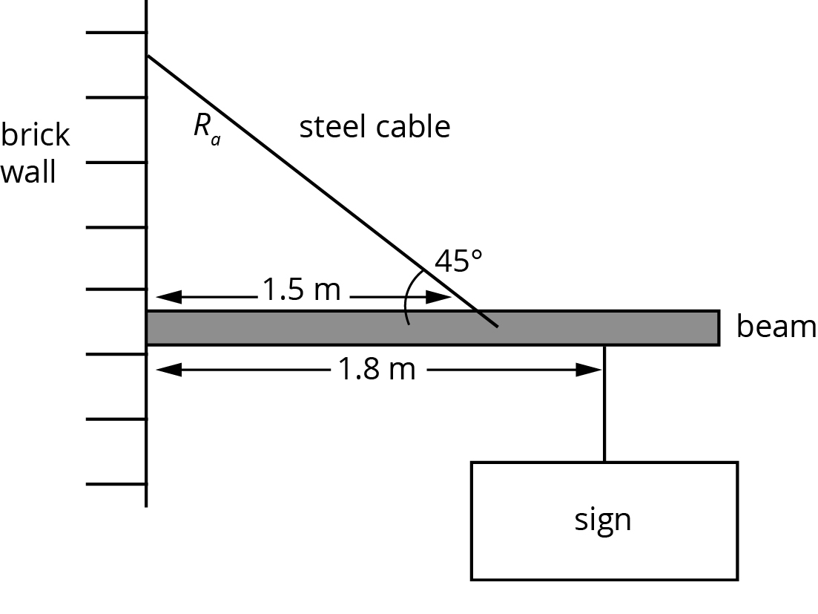

- State the conditions needed for this structure to be in equilibrium. (2 marks)

- Determine the tension in the steel cable. (6 marks)

